**Batch: B - 1**

**Roll No.: 16014022050**

**Experiment No.: 2**

|  |
| --- |
| Title: Implement vector data styling and raster data styling in QGIS. |

# Course Outcome:

# CO2: Apply the data analytics in the field of geospatial system.

# Books/Journals/Websites referred:

# QGIS Installation Link: <https://www.qgis.org/download/>

# Resources used:

# (Students should write)

# ---------------------------------------------------------------------------------------------------------------

# Algorithm:

# Vector Data Styling

# Step 1: Start QGIS and load your vector data (e.g., shapefile, GeoJSON, etc.). Go to Layer-> Add Layer -> Add Vector Layer -> Upload the code file

# 

# Step 2: Open the Layer Styling Panel

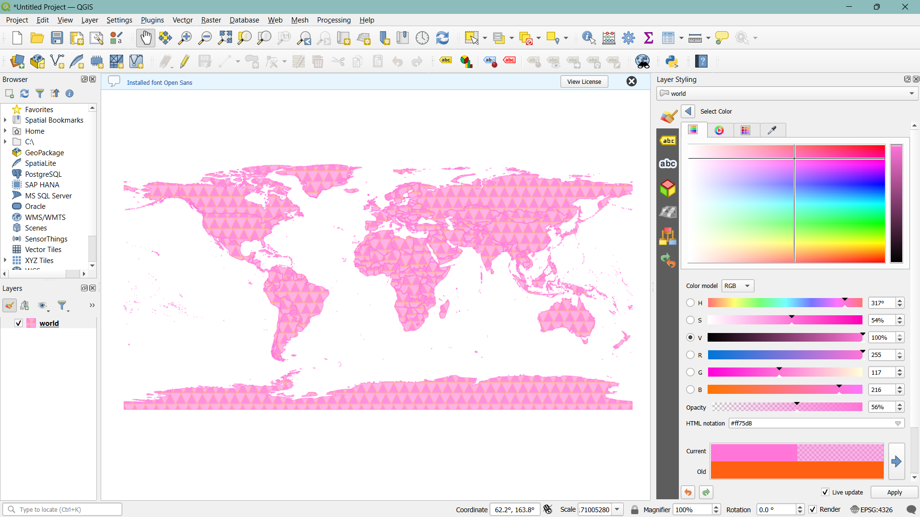

# Step 3: Select your vector layer in the Layers panel.

# 

# Step 4: Right-click the layer and choose "Properties" or click on the "Layer Styling" panel on the right.

# 

# Step 5: Select a Symbology Type: In the Layer Properties window, go to the "Symbology" tab. Choose a symbology type (e.g., Single Symbol, Categorized, Graduated).

# 

# Step 6: Single Symbol Styling: For simple styling, choose "Single Symbol." Select the symbol and click on the symbol to open the Symbol Selector. Customize the symbol's color, outline, transparency, and other properties.

# 

# Step 6: Categorized Styling: Choose "Categorized" to style the layer based on a categorical attribute. Select the attribute column and click "Classify" to generate unique symbols for each category. Customize each category's symbol by clicking on the symbol next to each category.

# 

# 

# Step 7: Graduated Styling: Choose "Graduated" to style the layer based on a numeric attribute. Select the attribute column and the classification mode (e.g., Equal Interval, Quantile). Click "Classify" to generate ranges and corresponding symbols. Customize each range's symbol by clicking on the symbol next to each range.

# 

# 

# Algorithm:

# Raster data styling

# Step 1: Start QGIS and load your raster data (e.g., GeoTIFF, JPEG, etc.).

# 

# Step 2: Open the Layer Styling Panel:

# 

# Step 3: Select your raster layer in the Layers panel. Right-click the layer and choose "Properties" or click on the "Layer Styling" panel on the right.

# Step 4: Select a Render Type: In the Layer Properties window, go to the "Symbology" tab.

# 

# Step 5: Choose a render type (e.g., Singleband gray, Singleband pseudocolor).

# 

# Step 6: Singleband Gray: For grayscale images, choose "Singleband gray." Adjust the Min and Max values or use the "Load Min/Max Values" button. Choose a Contrast Enhancement mode (e.g., Stretch to MinMax, Stretch and Clip to MinMax).

# 

# 

# Step 7: Singleband Pseudocolor: For continuous data, choose "Singleband pseudocolor." Select a color ramp and adjust the Min and Max values. Click "Classify" to generate a color map based on the selected color ramp.

# 

# 

# Step 8: Write an expression in the raster calculator.

Minimum –

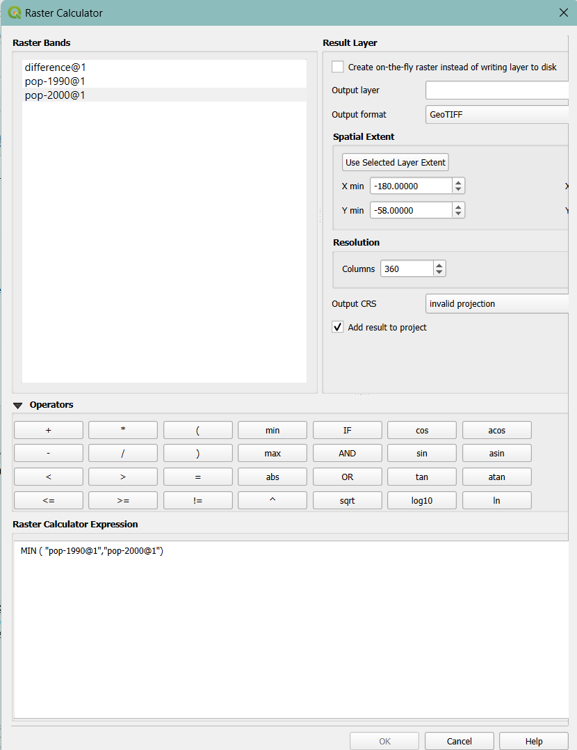

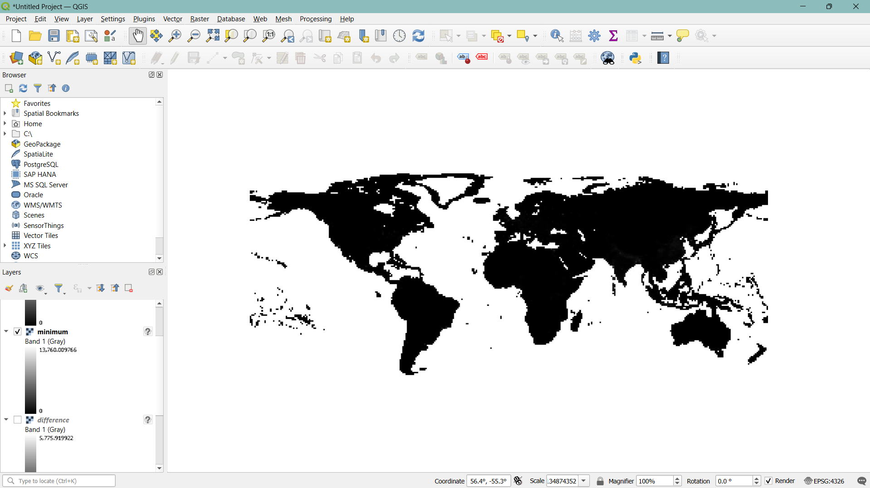

Difference –

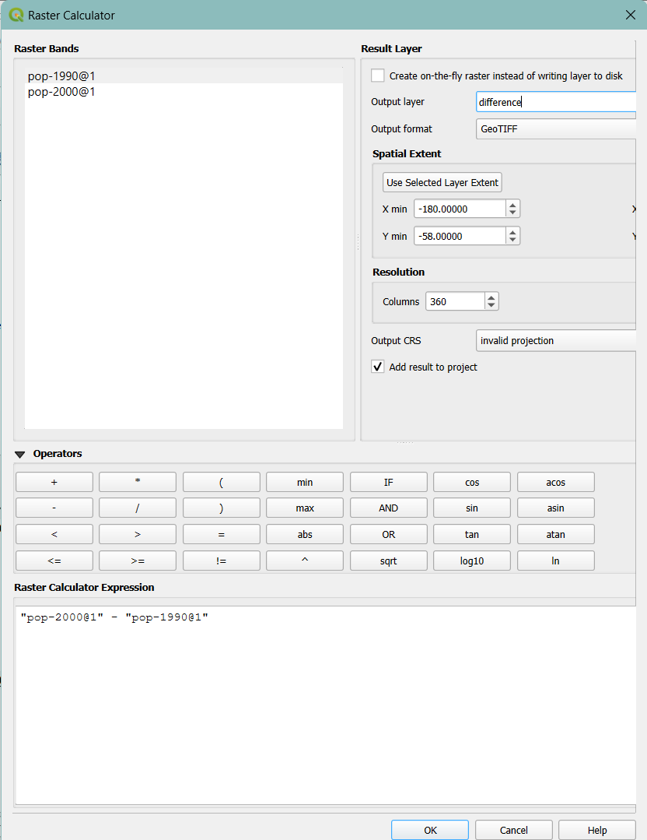

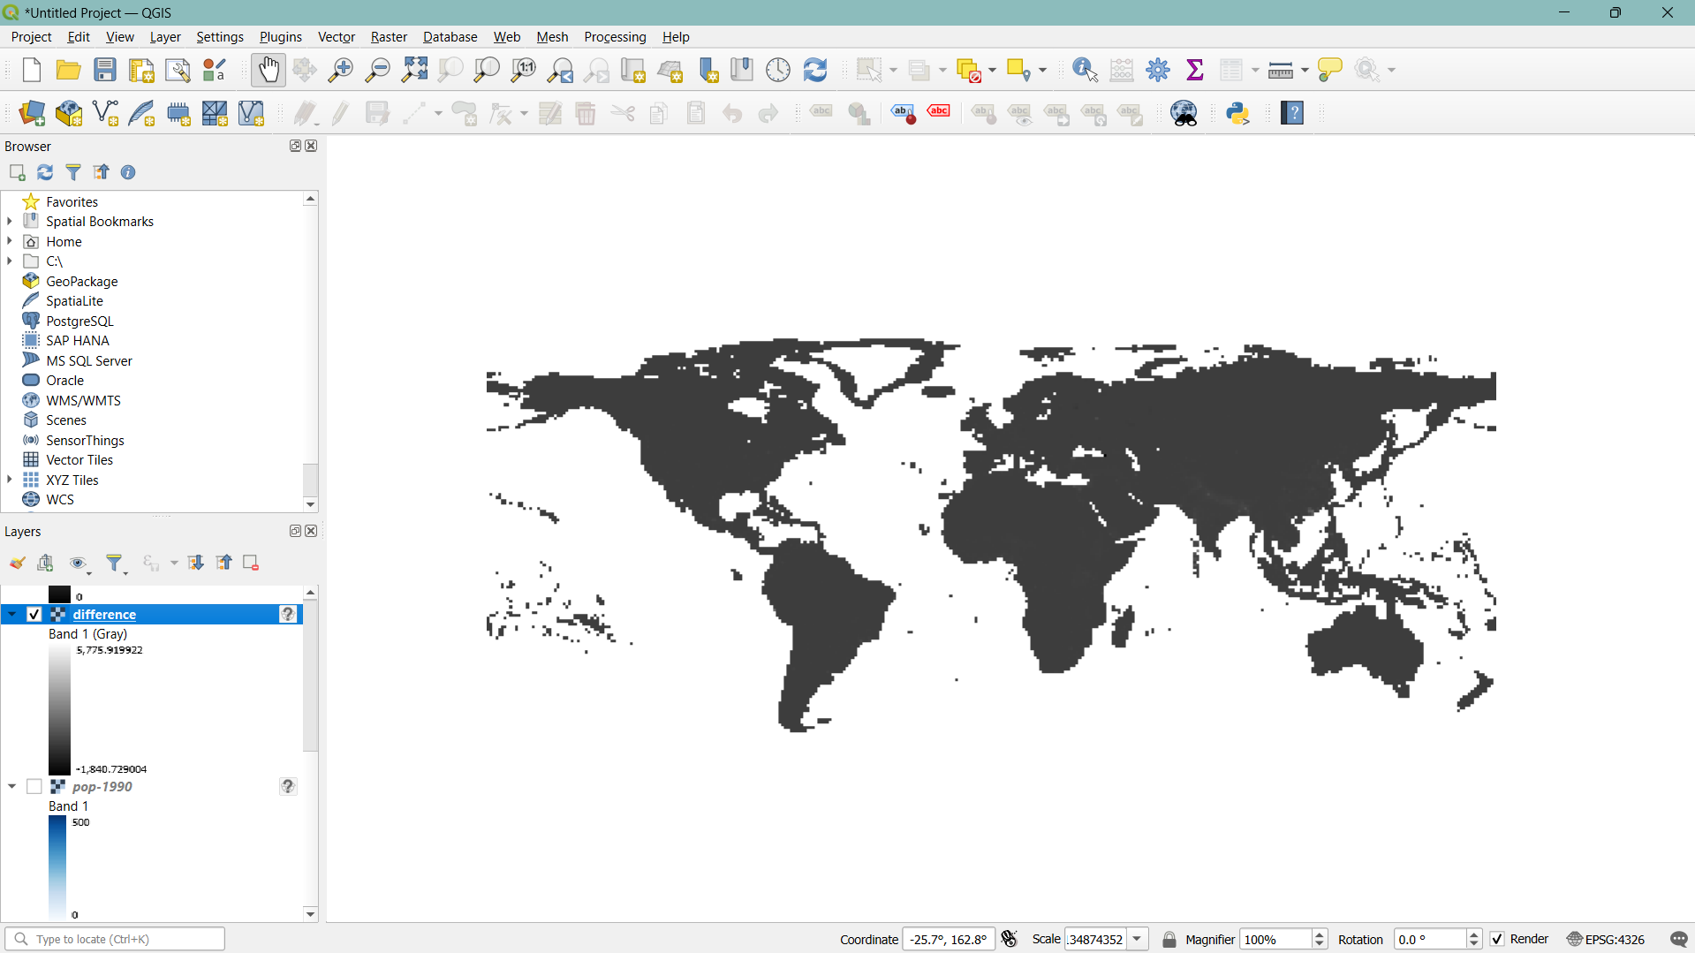

**Task:** Install QGIS Software version 3.38. Select different features and perform the vector data and raster data styling. Insert the output images for the respective task.

# Platform used by the student: QGIS

# Following points should be written by students:

# Different steps in Vector data styling and raster data styling.

# Steps in Vector Data Styling:

# Load Vector Data: Add your vector file (e.g., shapefile) to QGIS.

# Open Layer Styling Panel: Access it via right-clicking the layer and selecting "Properties" or using the Layer Styling panel.

# Select Symbology Type: In the Symbology tab, choose a style type (Single Symbol, Categorized, Graduated).

# Customize Styling: Adjust colors, symbols, and classifications based on your chosen symbology type.

# Steps in Raster Data Styling:

# Load Raster Data: Add your raster file (e.g., GeoTIFF) to QGIS.

# Open Layer Styling Panel: Right-click the layer and choose "Properties" or use the Layer Styling panel.

# Select Render Type: In the Symbology tab, choose a render type (Singleband gray, Singleband pseudocolor).

# Customize Styling: Adjust Min/Max values, color ramps, and classifications as needed. Use the Raster Calculator for advanced calculations.

# Conclusion:

# The experiment showed that QGIS integrates vector and raster data effectively, enhancing spatial analysis and decision-making. This demonstrates QGIS's capability to support comprehensive GIS applications with diverse data types.

# Post Lab Questions:

1. **How do different symbolization methods (e.g., simple symbols, graduated symbols, categorized symbols) impact the interpretation of vector data?**

# Simple Symbols: Uses the same symbol for all features, offering a uniform appearance. Best for visualizing the location of features without emphasizing differences.

# Graduated Symbols: Varies symbol size or color based on numerical attributes, making it easier to identify trends and patterns in data distribution.

# Categorized Symbols: Assigns different colors or symbols based on categorical data, highlighting distinct groups or categories within the dataset.

1. **How can attribute data be used to style vector layers effectively (e.g., using different colors for different categories or sizes based on numerical values)?**

# Categorical Data: Use different colors or symbols to represent distinct categories (e.g., land use types). This allows easy visual differentiation of feature types.

# Numerical Data: Use graduated symbols or color ramps to represent numerical values (e.g., population size). Larger symbols or darker colors can indicate higher values, helping in quick visual analysis of data patterns.

1. **Discuss in detail vector data styling and raster data styling.**

Vector Data Styling –

# Focuses on individual features (points, lines, polygons).

# Uses symbols, colors, and classifications based on attribute data to visually differentiate features.

# Effective for detailed map visualizations where feature-specific information is crucial.

Raster Data Styling –

# Deals with pixel-based data (e.g., elevation, temperature).

# Uses render types like Singleband gray or pseudocolor to represent continuous data.

# Involves adjusting color ramps, min/max values, and contrast to enhance visual interpretation of large datasets.